ART AND DESIGN CURRICULUM – Cultural connections AND CULTURAL CAPITAL

YEAR 7

TERM ONE
Traditional | Modern | Contemporary
Aboriginal Art AND INDIGNOUS AUSTRAIAN ARTISTS | POST impressionism – Van Gogh | Andy Goldsworthy - LAND ART

TERM TWO
Traditional | Modern | Contemporary
Greenman – myths and legends, Paganism, local community. Celtic ART | MATISEE – CUT OUT LEAVES AND ABSTRACT SHAPES | Mathew Williamson

TERM THREE
Traditional | Modern | Contemporary
Eugene Séguy ((1890 – 1985) – links to West African textiles and Science he was an entomologist – Art Nouveau period | TIMOROUS BEASTIES - DESIGNER COLLECTIVE | DAMIEN HURST

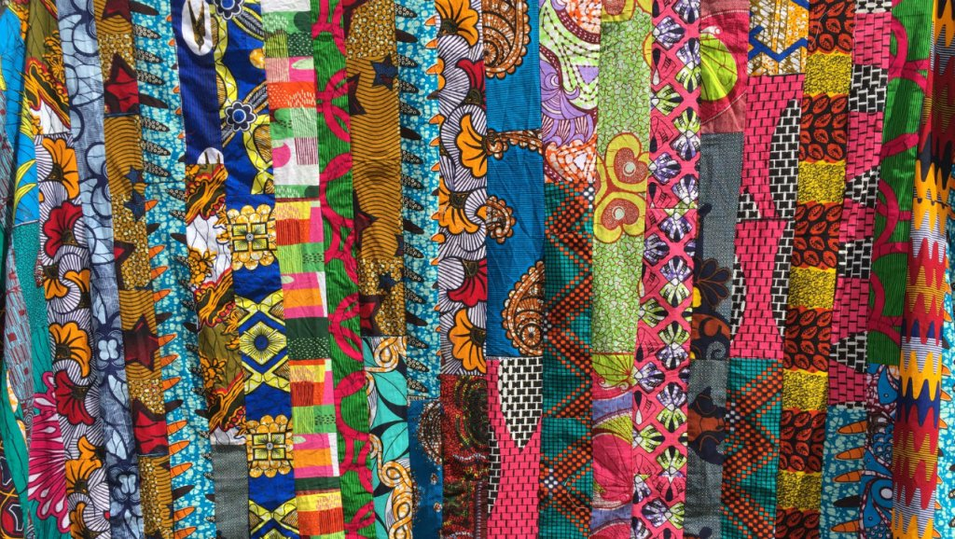
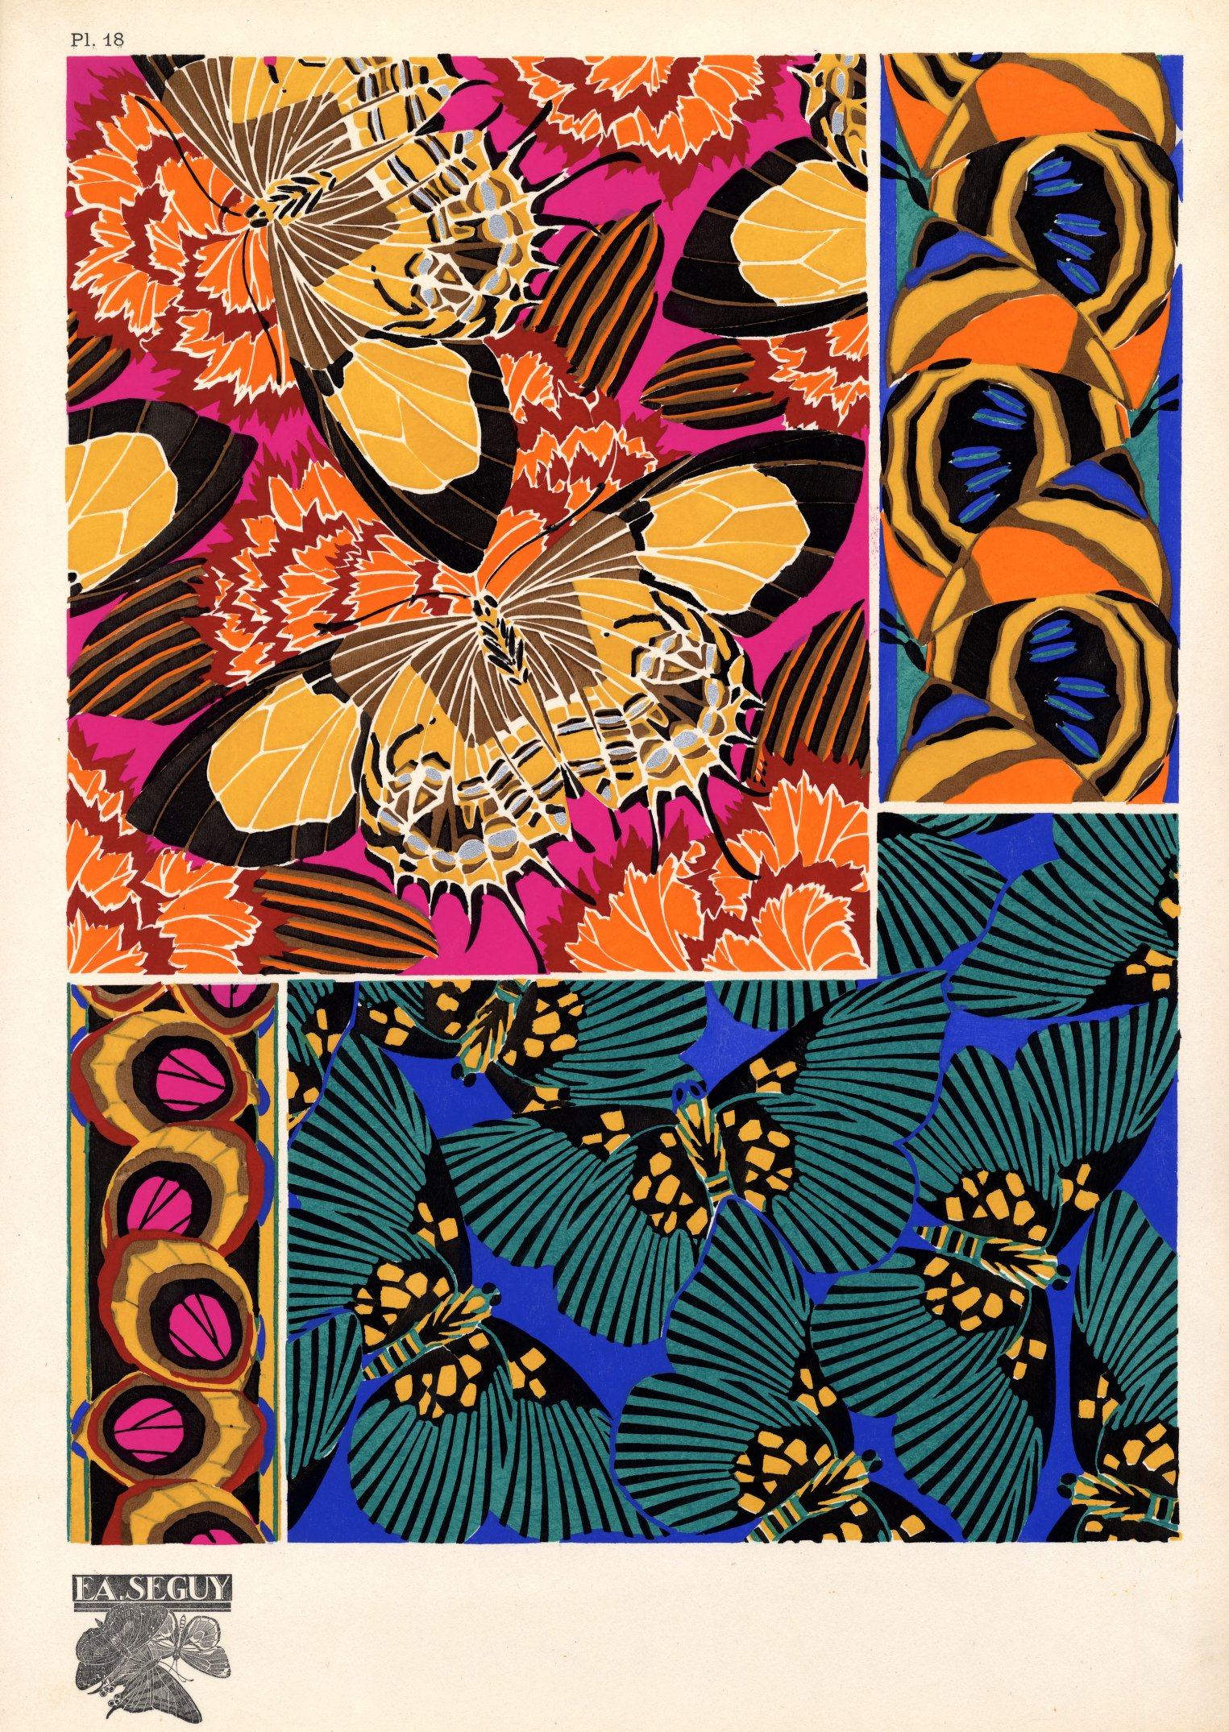
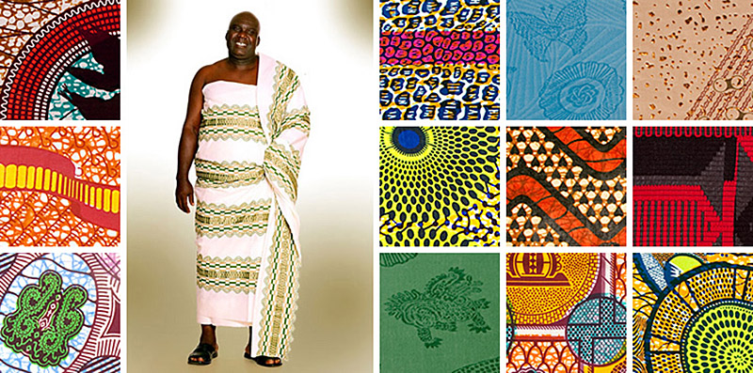

YEAR 8

TERM ONE
Traditional | Modern | Contemporary
Explore the Work of Ernst Haeckel – links between Science and Art | Maggie Hambling  Peter Chang | Lisa Stevens

TERM TWO – F AND F
Traditional | Modern | Contemporary
Katsushika Hokusai | Ben Nicholson | Yayoi Kusama, Japanese artist

TERM THREE
Traditional | Modern | Contemporary
Rembrandt | Alexander Calder  Frida Kahlo | Grayson Perry – British Artist

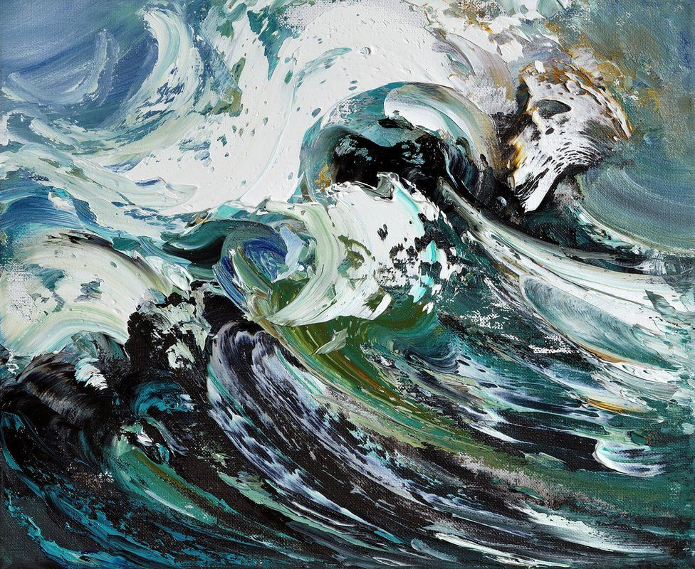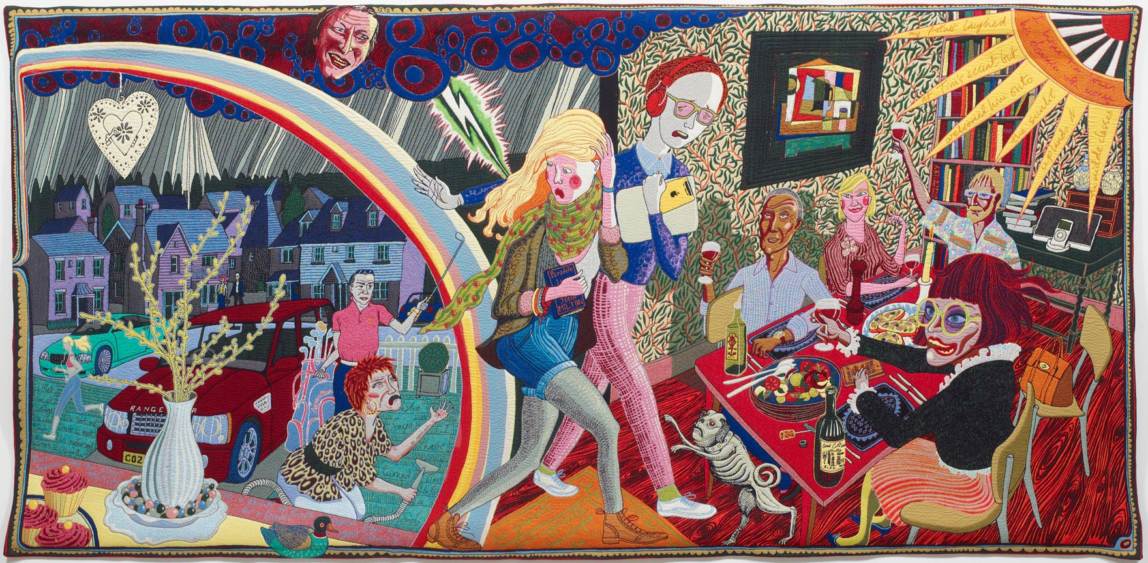

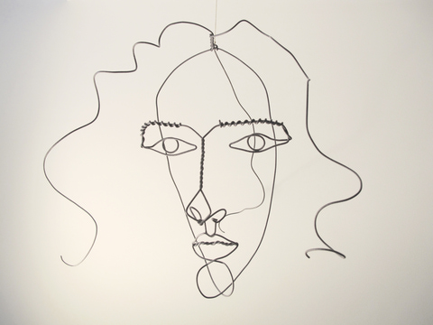

YEAR 9
TERM ONE
Traditional | Modern | Contemporary
CAVE ART | BASQUIAT | VIVIENNE WESTWOOD

TERM TWO
Traditional | Modern | Contemporary
JAPANESE ORIGINAMI AND PAPER FOLDING  J.H. JONES - Architectural drawings | ROBERT DELAUNEY  Bernd and Hilla Becher | IDRIS KHAN  IZZEY MIYAKE  IRIS VAN HERPAN  JANE BOWLER

TERM THREE
Traditional | Modern | Contemporary
FAUVISM | POP ART – ANDY WARHOL, ROY LITCHENSTEIN | SARAH GRAHAM  Takashi Murakami

Year 10/11

Urban environment
Ian Murphy (English)

Cultural Identity project

Explore the work Stephanie Ledoux (French Artist) who travels around the world capturing people from other cultures and places

Women artists – Claire Heathcote (British), Michele Caplan (American), Elly Smallwood (Canadian)

Independent free choice end of year 10 onwards

